**User Authentication and Registration:**

Allow users to create accounts and log in securely.

**Ride Requesting:**

Users should be able to request rides based on their current location.

**Real-time Driver Tracking:**

Users should be able to track the location of available drivers in real-time after requesting a ride.

**Payment Processing:**

Enable users to securely process payments for rides within the app.

**Driver Matching Algorithm:**

Develop an algorithm to efficiently match drivers with ride requests, especially during peak hours.

**Secure Payment Transactions:**

Implement a secure payment processing flow to protect user payment information.

**Offline Functionality:**

Allow users to request rides and track progress even in areas with limited or intermittent internet connectivity.

**Surge Pricing:**

Implement surge pricing logic and algorithms to adjust ride fares during high-demand periods.

**Performance Optimization:**

Identify and address performance issues to improve app responsiveness, considering factors like network latency and server response times.

**Localization Support:**

Provide support for multiple languages, currencies, and cultural norms to ensure a seamless user experience across different regions.

**User Feedback and Ratings:**

Allow users to provide feedback and ratings for drivers and overall service quality to maintain reliability and trustworthiness.

**Integration with Mapping and Navigation Services:**

Integrate external mapping and navigation services to provide accurate directions and estimated arrival times to users.

**Testing and Deployment:**

Conduct various types of testing including functional testing, performance testing, and user acceptance testing to ensure the quality and performance of the app before deployment.

1. **User Registration:**
   * **Main Features and Functionalities:**
     + Allow users to create accounts securely.
     + Collect user information such as name, email, phone number, and payment details.
     + Verify user identity through email or phone verification.
   * **Non-functional Requirements:**
     + Security: Implement secure authentication mechanisms to protect user data.
     + Scalability: Ensure the registration system can handle a large number of users without performance degradation.
2. **Ride Request:**
   * **Main Features and Functionalities:**
     + Enable users to request rides based on their current location.
     + Provide options for selecting ride preferences (e.g., car type, ride-sharing, etc.).
     + Notify users about ride status and estimated arrival time.
   * **Non-functional Requirements:**
     + Reliability: Ensure ride requests are processed accurately and promptly.
     + Availability: Maintain a high availability of the ride request system to handle user demands, especially during peak hours.
3. **Driver Management:**
   * **Main Features and Functionalities:**
     + Allow drivers to register and create profiles.
     + Enable drivers to manage their availability status.
     + Provide tools for drivers to accept or decline ride requests.
   * **Non-functional Requirements:**
     + Performance: Ensure quick response times for driver-related actions to improve user experience.
     + Data Integrity: Maintain accurate and up-to-date driver profiles and availability information.
4. **Real-time Tracking:**
   * **Main Features and Functionalities:**
     + Allow users to track the location of assigned drivers in real-time.
     + Provide updates on driver ETA (Estimated Time of Arrival) to users.
   * **Non-functional Requirements:**
     + Accuracy: Ensure the real-time tracking system provides accurate location data.
     + Responsiveness: Update user interfaces promptly to reflect changes in driver location.
5. **Payment Processing:**
   * **Main Features and Functionalities:**
     + Enable users to securely process payments for rides within the app.
     + Support multiple payment methods (e.g., credit/debit cards, mobile wallets, etc.).
     + Provide invoices and ride summaries for completed trips.
   * **Non-functional Requirements:**
     + Security: Implement robust encryption and authentication mechanisms to protect payment transactions.
     + Compliance: Adhere to relevant payment industry standards and regulations (e.g., PCI DSS).
6. **Review/Rating System:**
   * **Main Features and Functionalities:**
     + Allow users to provide feedback and ratings for drivers and overall service quality.
     + Aggregate and display driver ratings to help users make informed decisions.
   * **Non-functional Requirements:**
     + Accuracy: Ensure that user feedback and ratings accurately reflect the quality of service.
     + Fairness: Implement mechanisms to prevent abuse or manipulation of the rating system.

**Class Diagram**

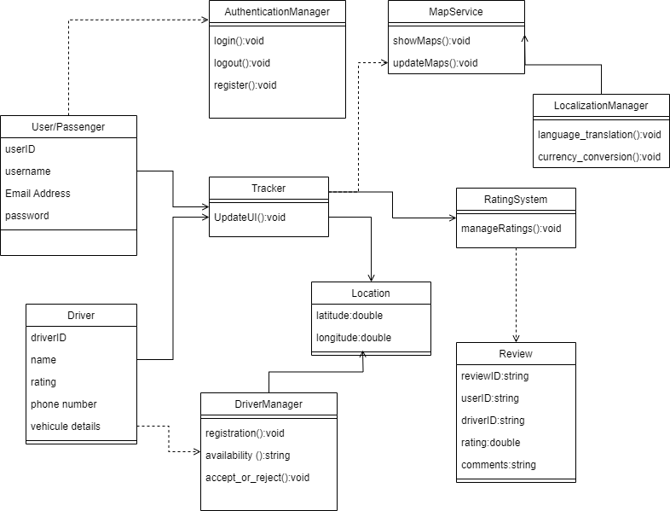

**Use Case Diagram**

